Required Practical Activity:
Density 2

Note:
This resource is designed as a review of the required practical activity, covering all possible skills that could be developed through the investigation. This resource can be adapted to suit the needs of your class, depending on which skills your class need support with.

In this investigation we will use the displacement method and a balance to determine the density of an irregularly shaped solid.

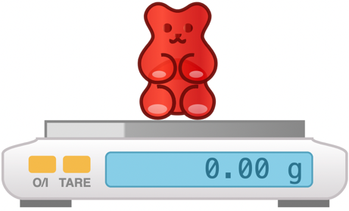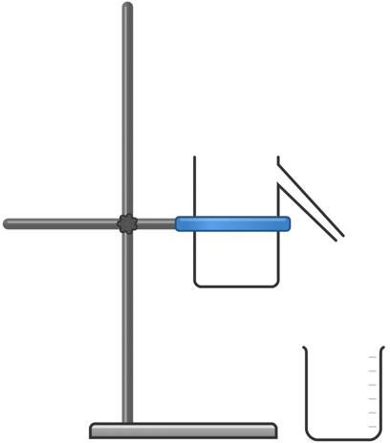

Method:

- Use the digital mass balance to measure the mass of one of the irregular shaped objects. Record this mass in your table.
- Secure the displacement can in the clamp stand so it is well-supported, and the spout is just higher than the top of your measuring cylinder. Select a measuring cylinder of an appropriate size for the object you will be measuring.
- Place an empty beaker beneath the spout of the displacement can. Carefully fill the displacement can with water until water leaks from the spout into the beaker. Wait until the spout stops dripping before proceeding to the next step.
- Remove the beaker and place your measuring cylinder beneath the spout.
- Slowly and carefully lower the irregular shaped object into the displacement can. You may wish to use a short length of cotton to do this to avoid having to drop the object and cause a splash.
- Measure and record the volume of water displaced from the can to the measuring cylinder. This will be equal to the volume of the object.
- Calculate and record the density of the irregular shaped object.

- Equipment:
- What measurements need to be taken in this investigation? | The volume of water displaced from the displacement can, the mass of the object.
- What is the most suitable piece of apparatus to take measurements with? Why? | A plastic measuring cylinder is accurate to 1 ml and is of sufficient resolution to measure the volume of displaced water.  A mass balance accurate 0.1 g or 0.01 g is of sufficient resolution to measure the mass of the object.
- Identify any hazards in this investigation. | Ensure the mass balance is able to withstand the weight of your chosen object. Some very sensitive balances can be damaged if too much force is applied.  If any water is spilled, clean it up immediately so as to avoid damaging electronic equipment or causing a trip hazard.
- Why is it important that the balance is properly zeroed before weighing your object? | If the balance is improperly zeroed it will not give an accurate measurement of the weight of the object. Zero the balance before placing the object on the balance.
- Why is it important to lower the irregular shaped object into the displacement can slowly and gently? | To avoid splashes – the only water lost from the can should be due to displacement from the irregular shaped object
- What units will we use for measuring the volume of displaced water? | Millilitres (ml).
- What is the difference between weight and mass? | Weight is the downward force of gravity on the mass. Mass will always be constant, whereas the force of weight will differ with gravity, for instance on other planets.
- What is the relationship between 1 cm³ and 1 ml? | They are equal.
- What is the equation to calculate density? | Density = mass / volume
- What will be our units for density if we measure mass in grams (g) and length in centimetres (cm)? | Grams per centimetre cubed, or g/cm³, or g.cm⁻³
- What are the S.I. units for density? | Kilograms per metre cubed, or kg/m³, or kg.m⁻³

- Results

Irregular shaped object | Volume (cm³) | Mass  (g) | Density  (g/cm³) | Density  (kg/m³)
Metal bolt | 11.0 | 93.0 | 8.5 | 8455
Plastic toy | 27.0 | 29.0 | 1.1 | 1074

- Explain why it is appropriate to round measurements taken with a ruler to the nearest millimetre. | This is as precise a measurement as can be inferred from the readings.
- Which object had the highest density? | The metal bolt.
- Which object had the lowest density? | The plastic toy.

